**Lesson 8 Demo 5  
Docker Registry**



Steps to be followed:

1. Pulling a Linux container
2. Pushing the image to the local repository
3. Running the new image

**Step 1: Pulling a Linux container**

1.1 Pull a recent version of the Centos Linux container.

***docker pull registry:2***

1.2 Run the registry in a new Docker container with port 5000 exposed

***docker run -d -p 5000:5000 \***

***--restart=always --name registry registry:2***

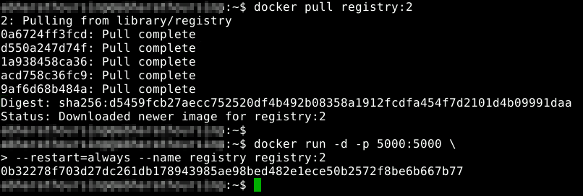



1.3 Pull another image from Docker Hub and store it in the local registry

***docker pull ubuntu***

1.4 Tag the image for the local registry

***docker tag ubuntu localhost:5000/ubuntu***

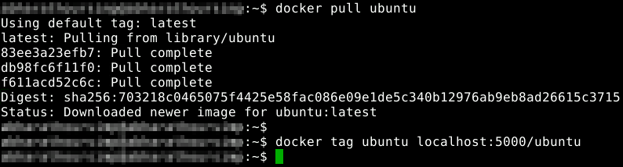



**Step 2: Pushing the image to the local registry**

2.1 Use the following command to push the image to a local registry:

***docker push localhost:5000/ubuntu***

2.2 Remove the image from the local cache

***docker rmi ubuntu***

2.3 Confirm that it has been removed

***docker images***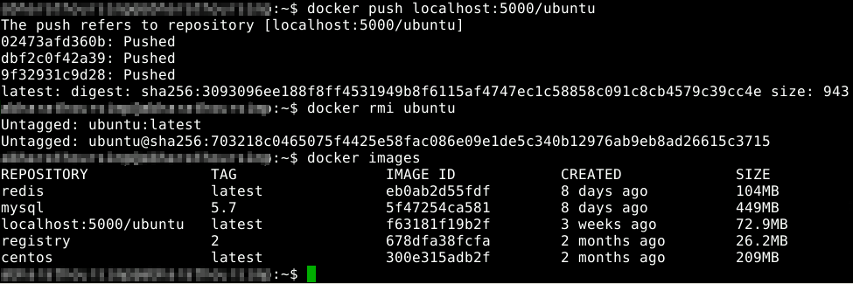

**Step 3: Running the new image**

3.1 Pull the image from the local registry

***docker pull localhost:5000/ubuntu***

3.2 Confirm it is in the local cache

***docker images***

3.3 Run the new image

***docker run -it --rm localhost:5000/ubuntu /bin/bash***

3.4 Exit the container

***exit***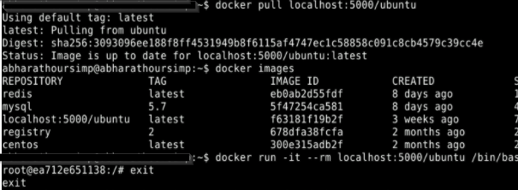

3.5 Clean up the images and containers

***docker rm -f $(docker ps -aq)***

***docker rmi $(docker images -q)***